10.10.2019

Dr. Lori Crosby

Yolanda Johnson

Neha Mann

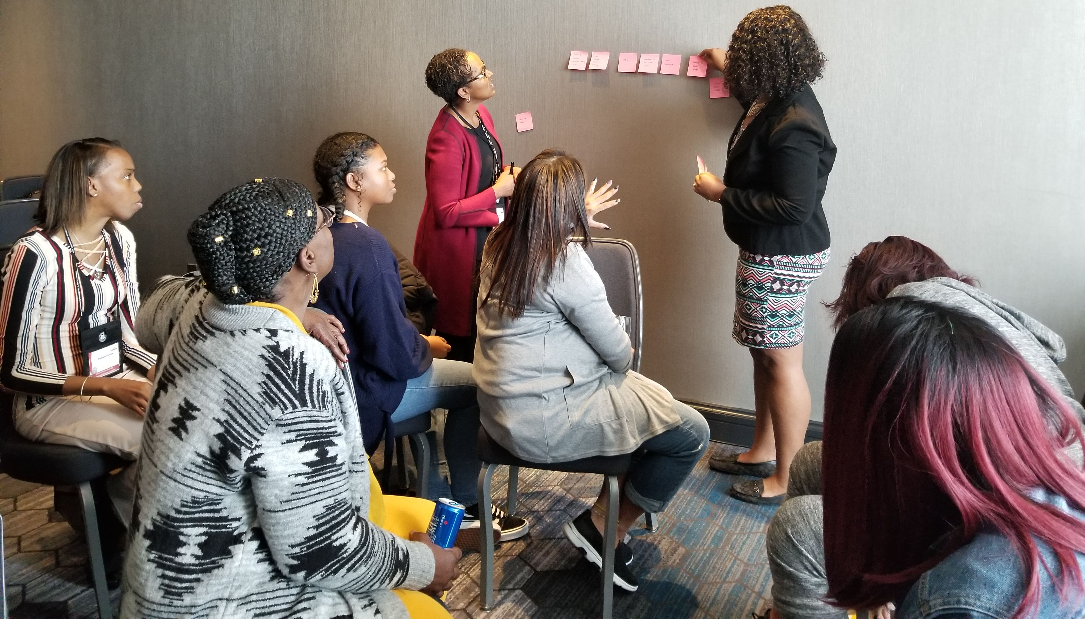
2019 Annual National Convention, SCDAA
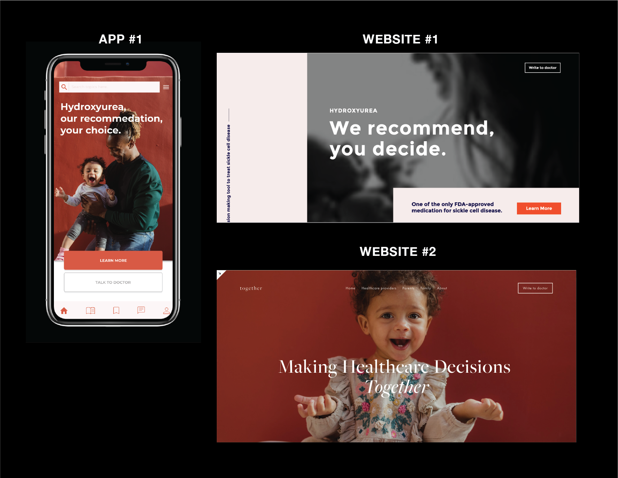
The workshop was designed as a co-design session to capture feedback and first impressions on 3 tools:
- An app for patients to learn about Hydroxyurea(HU)
- A website to learn about SDM for HU
- A website to learn about shared decision making(SDM)
Total participants: 20 women
The participants were divided in 4 teams of ~5 members:
- Team A: Patient/Parents 1
- Team B: Patient/Parents 2
- Team C: Healthcare providers
- Team D: Community/Family

Activity 1: Co-designing Learning tracks
Each team was given topics(on post its) that they had to meaningfully priorities as an ideal learning track for patients/healthcare providers/community.
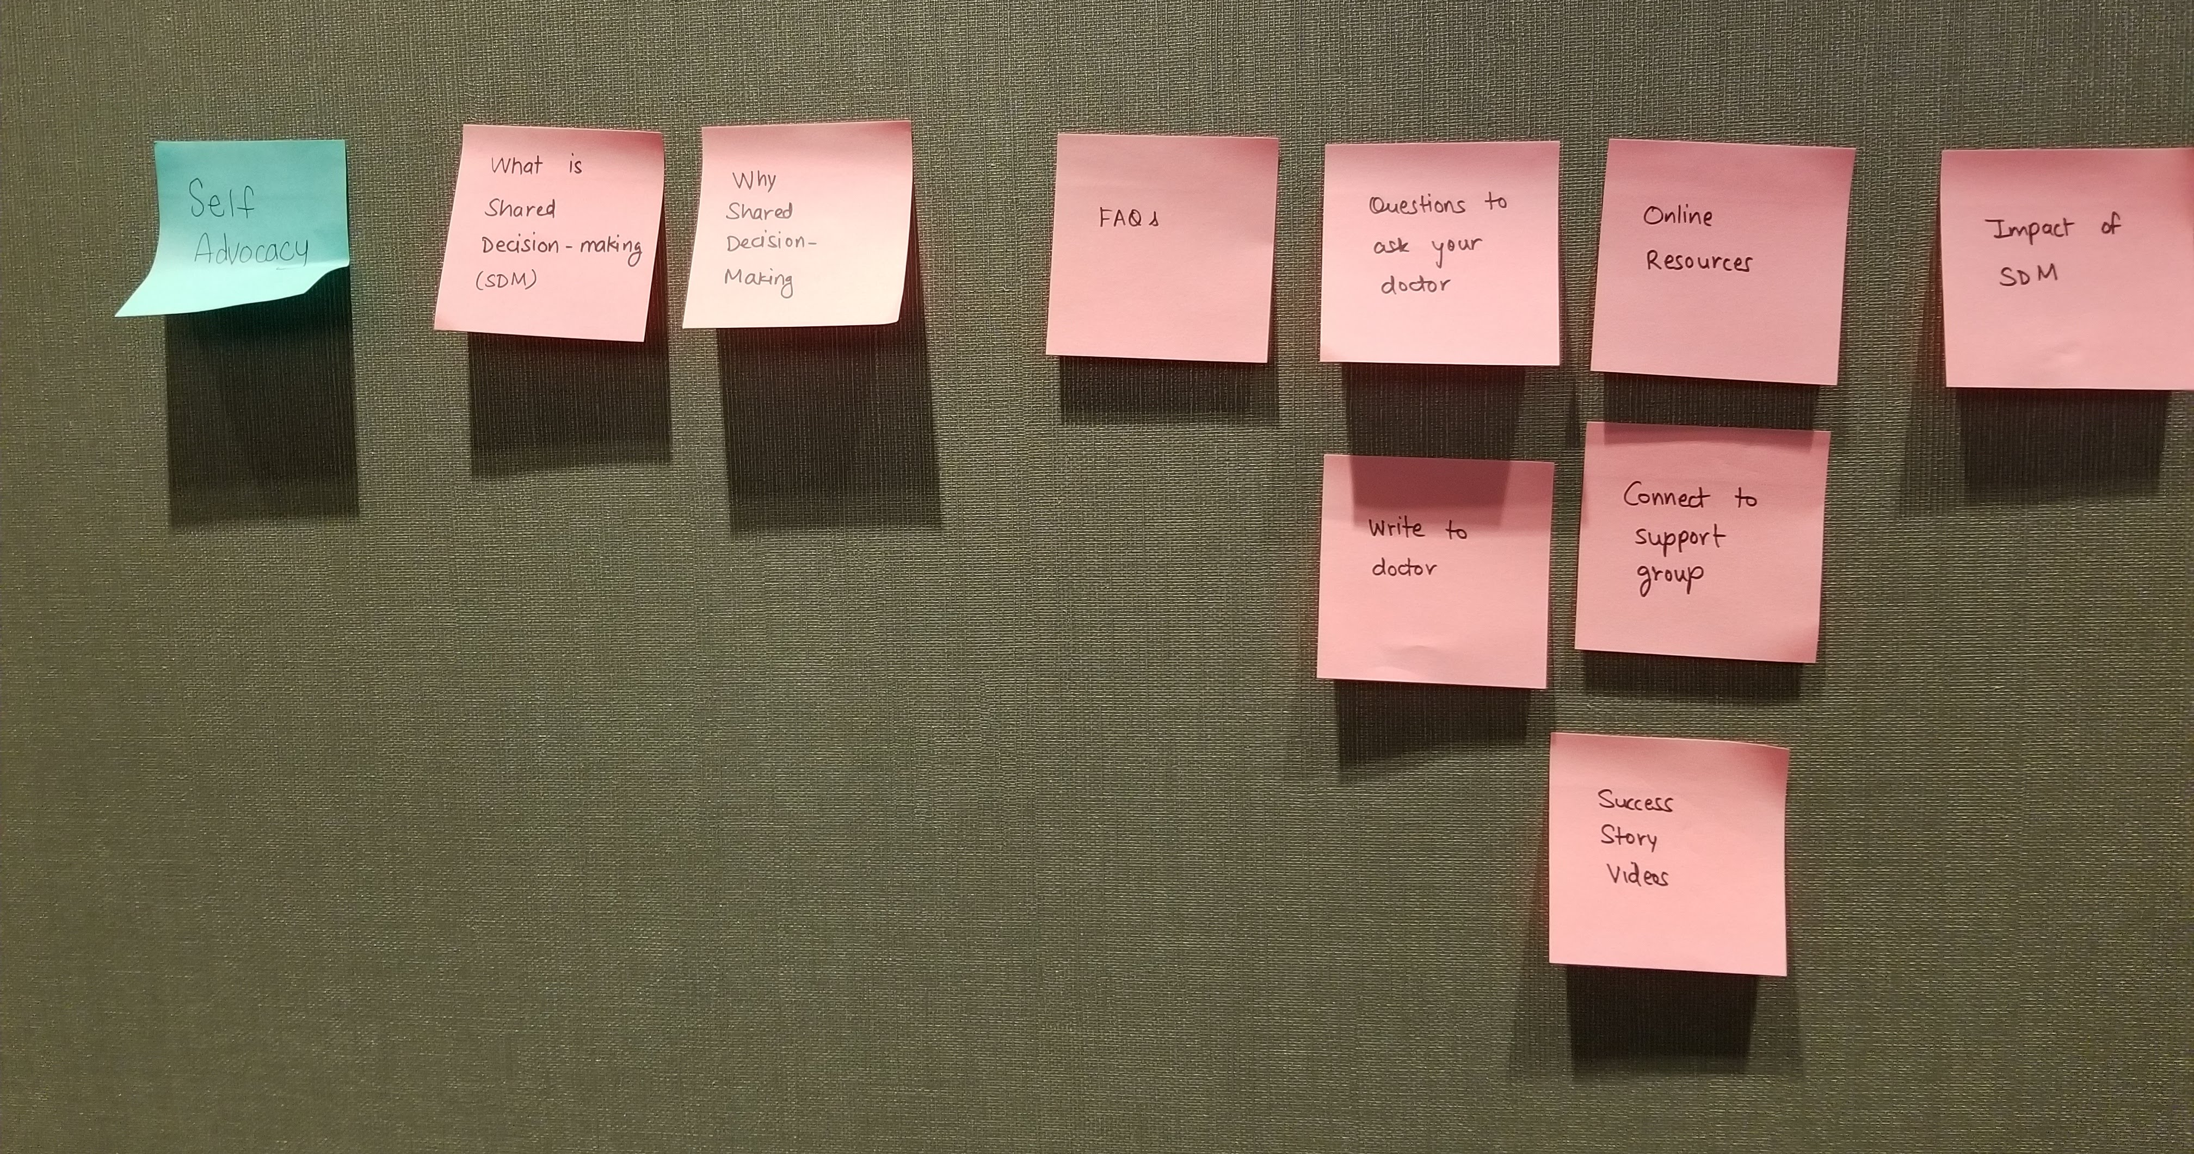
Feedback:
Figure 1. Patient/Parents (A,B)
- Patients added Self-Advocacy as the most important topic for them
- They wanted to do their own research before connecting with a support group or watching videos of other’s success stories.
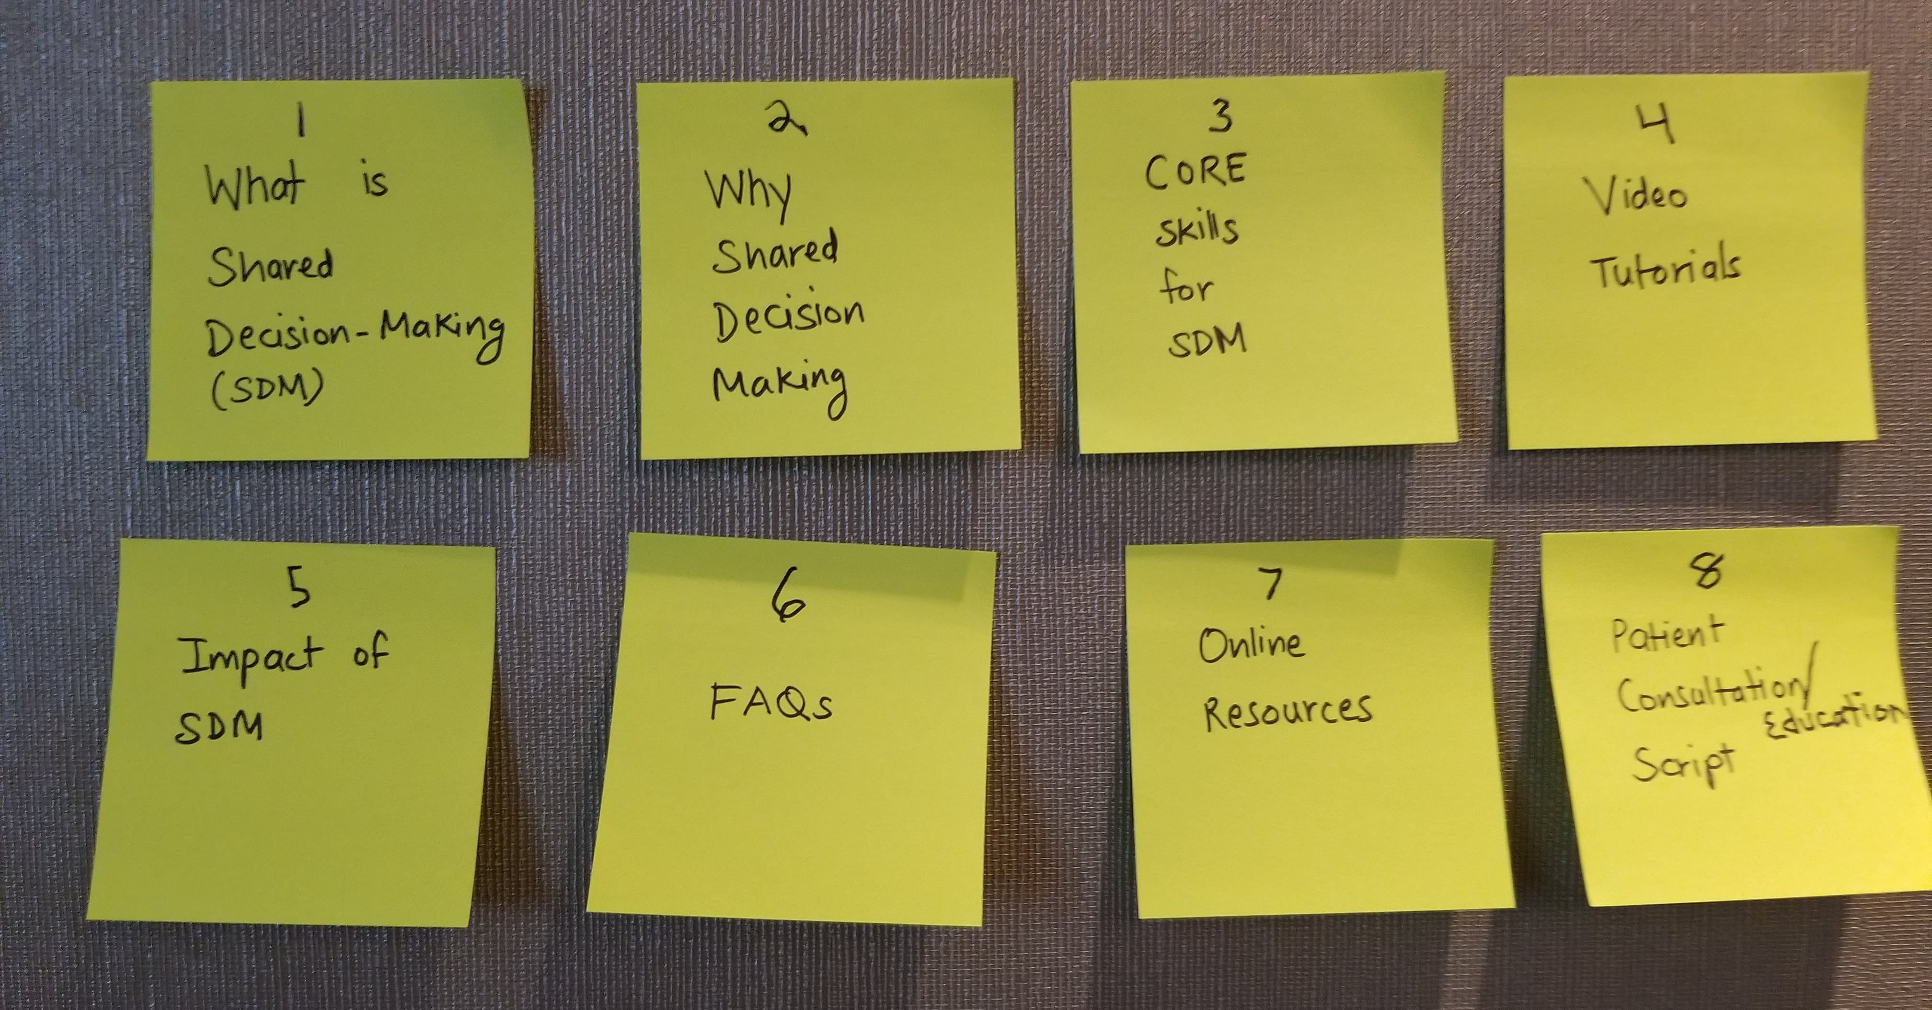
- The group strongly disregarded the need of a ‘write to a doctor’ as they believed it was unrealistic and unresponsive as a method, especially during urgent episodes.
Figure 2. Healthcare Providers (C)
- Healthcare providers set a linear learning path, which matched the workflow of the current tool.
- They shared they would all engage in steps 1-4 and steps 5-8 will be extra but good-to-have.
Figure 3. Community/Family (D)
- Community members also made a linear learning path, similar to the current workflow.
- They moved ‘Impact of SDM’ way higher in the sequence.
- They also added ‘Success story videos’ as a topic of interest.

Activity 2: Improving User experience
2.1 BLINK TEST
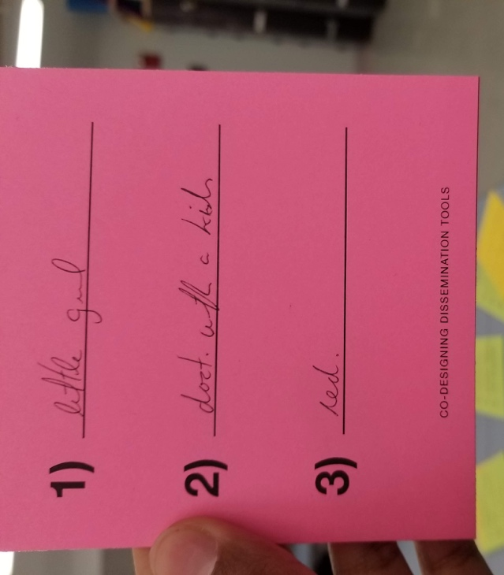
The participants were all shown the homepage of the tools for a few seconds and they had to write 3 things that they remembered.
- HU App: objective observations, like picture, color, identifying that it is an app for mobile.
  - Father and child
  - Hydroxyurea
  - Red color
  - Choice
  - Buttons
  - App
  - Cell phone

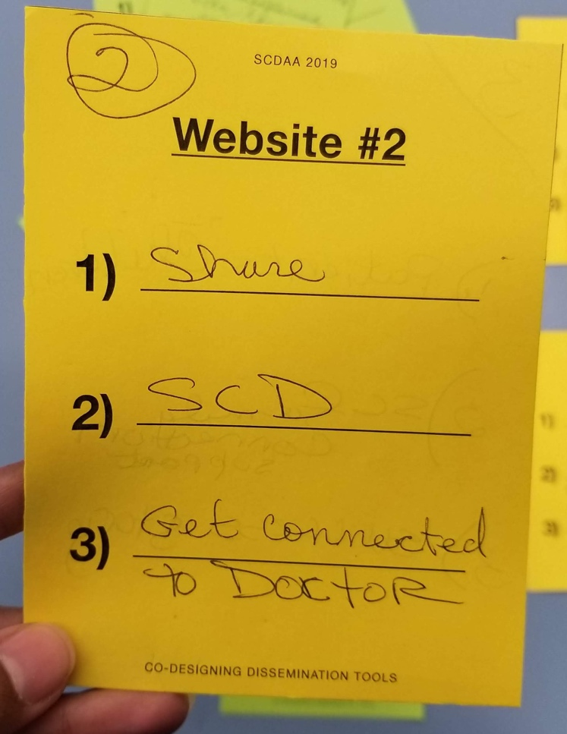
- Website for SDM for HU:
  - Shared Decisions
  - What is SCD?
  - Get connected to doc
  - Black and white
  - Orange
  - We decide
  - Contact info
  - Personal stories

- Website for HU:
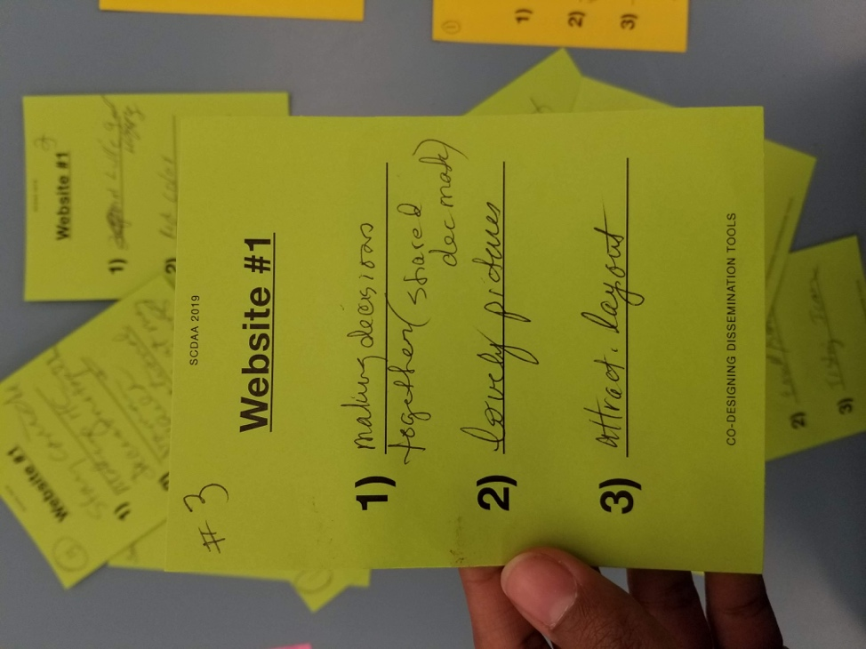
  - Healthcare/shared decisions
  - Aww/happy
  - Happy baby girl
  - Clear/easy/plain layout
  - Red and white
  - Success Stories
  - Doc with kid
  - Diversity
  - Stay connected

2.2 SCENARIOS AND TASKS
Each team was given several scenarios and tasks to get from point A to B in the tool they were testing. 1-2 team members executed the task, 1 member kept track of time and 1 member counted the no. of steps.
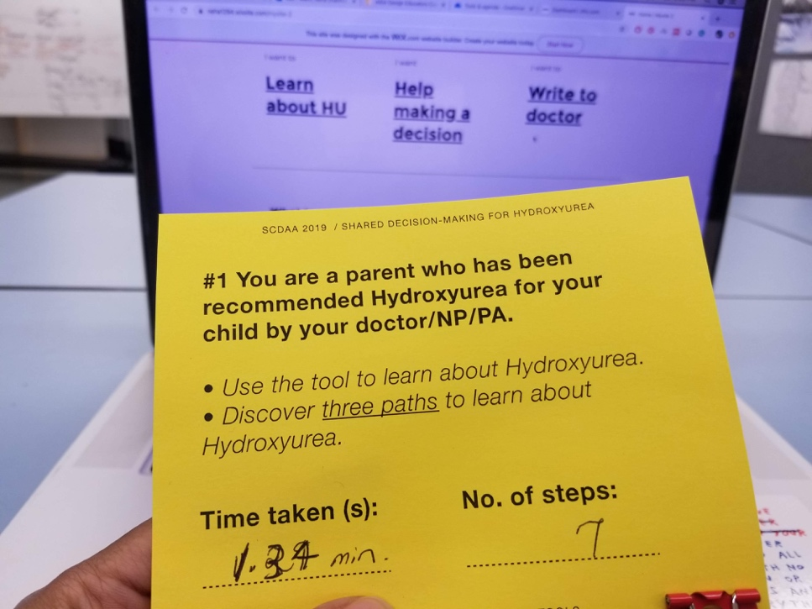
The attempts were also screen and audio recorded.

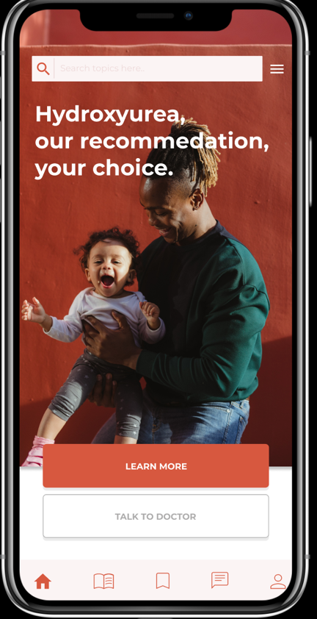
TEAM A: Patients/Parents 1 testing HU app
- Easily found the glossary in a single try
- Were able to save the content to a collection
- Struggled with the prototype’s limited functioning. At one step, they tried several times to click the right button, but due to the low fidelity of the prototype they got stuck.
- Could easily search and read the benefits and side effects of HU.
- Didn’t follow the exact tasks, but used the tool successfully to learn about HU.
- Said the app was intuitive and easy to use apart from some buttons that were tough to click.

TEAM B: Patients/Parents 1 testing HU app (audio not available)
- Easily found the glossary in a single try
- Were able to save the content to a collection
- Couldn’t locate the collections tab, explored other menu options to find it
- When they found it, the button didn’t work very well - confusing them.
- Struggled with limited interactions available on the prototype at the current fidelity.
- Easily located benefits and side effects.
- On average, tasks took longer than expected but the number of steps was good. (possibly because of poor clickability of some buttons)
- Suggested adding FAQs to table of content (side menu)
- Emphasized on having a functional search bar. Said it would make all tasks much simpler.

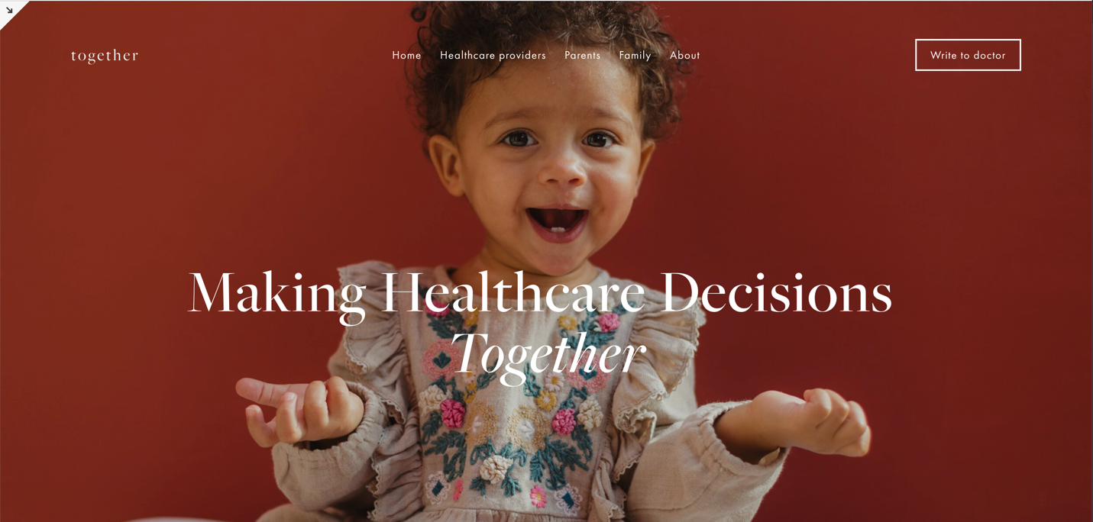
Team C: Healthcare providers testing website for SDM
- Suggested adding search box
- Suggested adding a Help section
- In the video tutorials sections, there should be two sections for doctors and parents
- Suggested adding drop downs in the top menu bar
- Easily found and interacted with Core Skills
- Easily navigated to Video tutorials and found it an essential element in their learning track
- The homepage background image had a great emotional response
- The distinctions between the main categories needs to be bigger and bolder
- The text in general was difficult to read and could be larger and higher in contrast
- Suggested quick ‘picture tutorials’ for using SDM in their practice

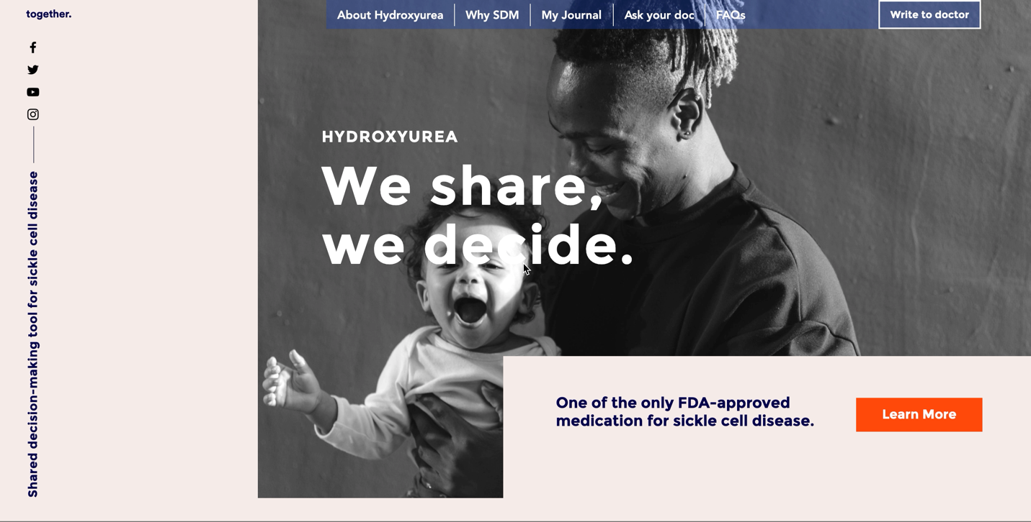
Team D: Community/Family testing website for SDM for HU

- The team was confused with the wording of the scenario.
- Eventually, they found multiple ways to access information on HU
- Confused with the location of pros and cons list in journal
- Easily filled the journal, liked the interaction
- Intuitively used drop downs, filled responses in pros and cons
- Suggested drop downs in homepage frozen menu, that explained the contents of the page
- Couldn’t attempt 3rd task, indicating they took the max time in executing the tasks.

